Analysis Of Birth Chart Of Mr. ……………… For Trading In Stocks & Commodities
Based On Gann Astrononamy

By Swayam Academy

 Gann Astrononamy

Introduction
William Delbert Gann (1878 – 1955 ) was born on a cotton ranch on June 6, 1878, in Lufkin, Texas. He displayed a strong aptitude in mathematics during his early years, completed a high-school education, and started trading in 1902 at the age of 24. By his own admission, Gann’s early trading was based on “hope, fear and greed,” all of which he later realized were not compatible with a successful trading strategy. After losing significant sum of money, Gann began to observe that markets followed mathematical laws and certain time cycles. He began studying this interaction diligently, even traveling to England, India, and Egypt to research mathematical theory astrology and historical prices.
Gann issued annual market predictions of major moves and exact support and resistance levels. Newspapers around the country kept tract of his predictions for 1921, 1922, and 1923, substantiating his accuracy. In January 1929, he issued an annual forecast that read: September-One of the sharpest declines of the year is indicated. There will be a loss of confidence by investors and the public will try to get out after it is too late….A “Black Friday” is indicated and a panicky decline in stocks with only small rallies. His facility in analysis and prediction extended to areas other than the market. He predicted the exact date of the Kaiser’s abdication, the end of World War 1, and the elections of Presidents Wilson and Harding. Gann also predicted the occurrence of World War II thirteen years in advance.
As per Gann all stocks and commodities vibrate and this vibration is in accordance with both their own individual energy/ vibration (i.e. internal vibration) and also in accordance with energy/ vibration transmitted through space (i.e. external vibration). The overall energy/ vibration of a stock or commodity is reflected in its price
Through his research on years of market data Gann has concluded that an Individuals birth chart plays a very important role in his/her trading gains and losses. Gann has himself experienced where-in he made 200 trades without any loss and from 201’st trade he started making loss and things got so worse that he lost his principle money also. Later when he learned Astrology he realised that it was when Saturn who came to his birth house he started loosing money. The enclosed analysis of individuals birth chart is done based on W D Gann’s Astrononamy where-in he combined Astrology and Astronomy .
www.stocktradingfundamentals.com 01
Gann Astrononamy

Summary Of Birth Chart

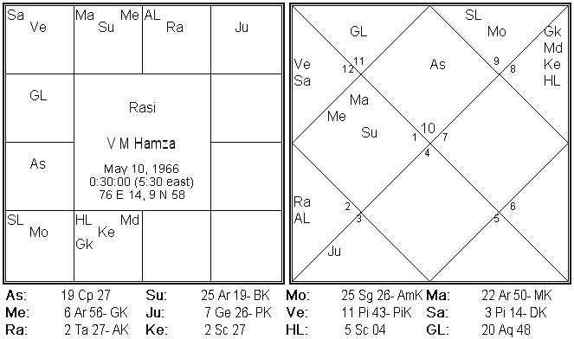
Birth House (Lagnam) Capricon ( Makaram )
Birth Star (Nakshatra) Poorvashada ( Puradam )
Birth House Lord Saturn
Planet Having Strength Venus, Saturn , Sun , South Node , Mars
Weak Planets Mercury, Jupiter , Moon
Best Sectors For Trading FMCG , Capital Goods , Gold, Metals , Glamor
Sectors To Avoid Oil & Gas , Banking , Sports Related
Direction To Sit For Trading Facing West
Companies To Choose Companies having Base in Gujarat, Mumbai ,Goa
Companies To Avoid Companies having Base in Calcutta, Chennai

www.stocktradingfundamentals.com 02
Gann Astrononamy

Planetary Cycles
Or
Dasas

www.stocktradingfundamentals.com
Gann Astrononamy

Significance Of Planetary Cycles Or Dasas
A dasas is a period of time during which one's life is influenced or governed by a particular planet. For example, the shortest period, the Sun period, lasts six years, while the longest period, Venus, lasts twenty years. These cycles unfold in a fixed sequence and comprise 120 years before they repeat. The order of the cycles is:
Ketu (Moon's South Node): 7 years
Venus: 20 years
Sun: 6 years
Moon: 10 years
Mars: 7 years
Rahu: (North Node) : 18 years
Jupiter: 16 years
Saturn: 19 years
Mercury: 17 years.
Where the cycle begins is based on the exact position of the moon at the time of birth. For example, when Sensex started trading it was in Sun Cycle from 08.10.1985 to 09.10.1991 after that it was Moon Cycle from 09.10.1991 till 09.10.2001 and then Mars cycle for 7 years and now its Rahu cycle which is going since 08.10.2008 onwards till 09.10.2026. So the native will experience events based on the planets position , with whom its placed and where its placed.

www.stocktradingfundamentals.com 03
Gann Astrononamy

Planetary Cycles – Vimsottari Dasha

Primary Cycle – Maha Dasas
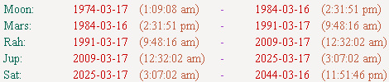
- Native is having Jupiter cycle from 17.03.2009 to 17.03.2025.
- Jupiter is 3rd house and 12th house lord sitting in 6th house is a mixed position.
- 17.03.2009 to 17.03.2013 native need to trade very cautiously avoid banking , NBFC.
- 17.03.2013 to 17.03.2017 recommend native to keep away from trading and blind speculation activity. .

Sub-Primary Cycle -- Antardasa
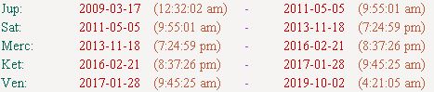
- 17.03.2009 to 05.05.2011 native had Jupiter cycle.
- 17.03.2009 to 17.04.2010 was good and 17.04.2010 to 17.04.2011 is bad.
- 05.05.2011 onwards its Saturn cycle which is the birth house and 2nd house lord sitting in 3rd house with Venus – can trade in IT Stocks , Gold.
- 18.11.2013 onwards its Mercury cycle which is 6th house and 9th house lord sitting in forth house with a enemy – initial one year till 18.11.2014 time to be very cautious.

www.stocktradingfundamentals.com 04
Gann Astrononamy

Planetary Cycles – Vimsottari Dasha

Micro-Primary Cycle – Prathyantaradasasas

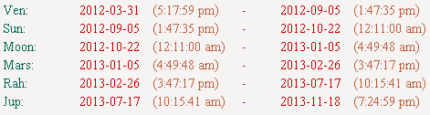

- From 31.03.2012 onwards till 05.09.2012 its Venus cycle .
- Venus is 5th and 10th house lord sitting in 3rd house with birth lord. Good period to trade in Bullion, Glamour related stocks.
- 05.09.2012 onwards its Sun cycle , 8th house lord sitting in 4th house is not comfortable. . Keep away from trading.
- 05.01.2013 its Moon cycle which is 7th house lord sitting in 12th house again not comfortable. Keep away from trading.
- 05.01.2013 onwards its Mars cycle which is 4th and 11th house lord sitting in own house with Sun excellent period to trade and gain profits. Can bet on Metals.
- 26.02.2013 onwards its Rahu cycle which is 2nd house co-lord sitting in 5th house can trade in Gold and Glamour related stocks.

www.stocktradingfundamentals.com 05
Gann Astrononamy

Transit Charts
Analysis

www.stocktradingfundamentals.com 06
Gann Astrononamy

Transit Chart

June 15th 2012

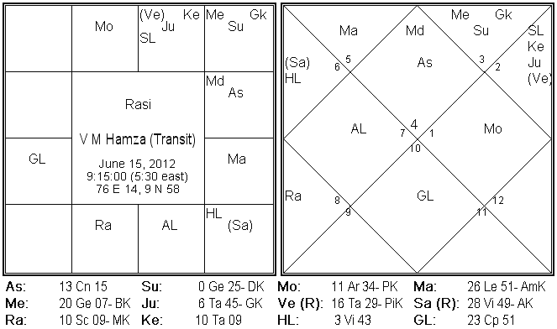

- Birth lord Saturn in 9th house friend house is good period to trade in IT and Technology companies , Telecom.
- Moon the 7th house lord sitting in 4th house good period can trade in Oil and Gas, Gold.
- Jupiter sitting in fourth house enemies house not comfortable avoid banking stocks.
- Venus is own house with Mars in 90 Degree not comfortable to trade in Agri products.
- Sun + Mercury in 6th house and Saturn in 90 Degree is not good for trading .
Overall with Sun and Jupiter in awkward position suggest to keep away from trading activity.

www.stocktradingfundamentals.com 07
Gann Astrononamy

Transit Chart

July 15th 2012

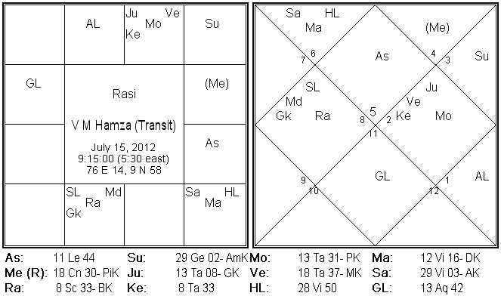

- Birth house lord Saturn in 10th house along with Mars its enemy ( Mars sitting in enemies house not comfortable) is not a good position to trade .
- Sun the 8th house lord sitting in 6th house not comfortable keep away.
- Jupiter , 3rd and 12th house lord sitting with enemy again not comfortable.
- Mercury 6th and 9th lord sitting in enemies house again not a good position.

Overall very bad position of almost all Benefic planets time to be very cautious and strongly recommend to keep away from trading and any finacial activity.

www.stocktradingfundamentals.com 08
Gann Astrononamy

Transit Chart

Aug 15th 2012

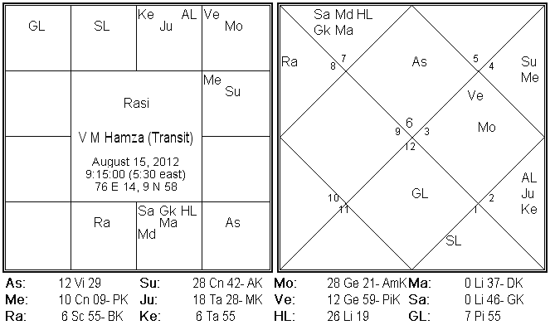

- Birth house lord Saturn along with its enemy in 10th house not a comfortable position for work etc. Avoid trading in IT , Metals.
- Jupiter in enemies house avoid banking.
- Sun + Mercury in 7th house (Moon’s house ) good if you trade from Spouse’s account. Go with FMCG , Banking.
- Venus with its enemy Moon not to trade in Gold , Agri Sector for these few days.
Overall mixed position, can trade in Banking, FMCG.

www.stocktradingfundamentals.com 09
Gann Astrononamy

Shubha
Labha

www.stocktradingfundamentals.com

